Electronic Variation To Contract (VTC) System

User Guide For Approvers
18 October 2011

Contents
1 Introduction 3
2 Accessing the approval page 3
3 Approving/Rejecting a VTC 4
4 Reminder Emails 5
5 Final Acknowledgement Email 7

Introduction
The Electronic VTC system is intended to streamline the remuneration process for the Remuneration team in HR. It is an online workflow system which creates, audits and completes variation to contracts.
This user guide has been prepared as a guide for approvers to use the system. Approvers can either be the area approver and optionally the releasing area approver. It details the steps involved for completing the following main tasks:
- Accessing the approval page
- Approving/Rejecting a VTC

Accessing the approval page
The user will receive an email which will indicate that an action is required from him/her. An example of the email is displayed below.
Screen 1
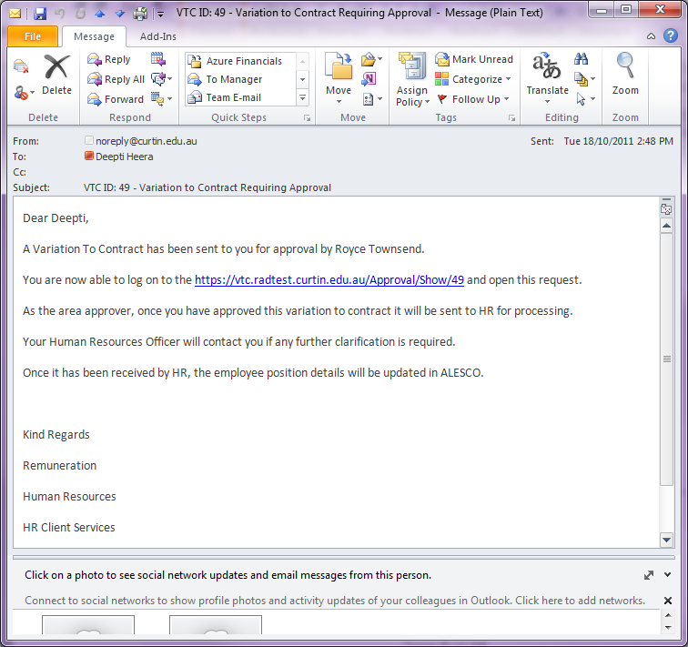

To access the approval page:
- Select the link provided in the email. This will direct you to the login page of the application.
- Log in using you oasis staff credentials.
The following page will then be displayed upon successful login.
Screen 2
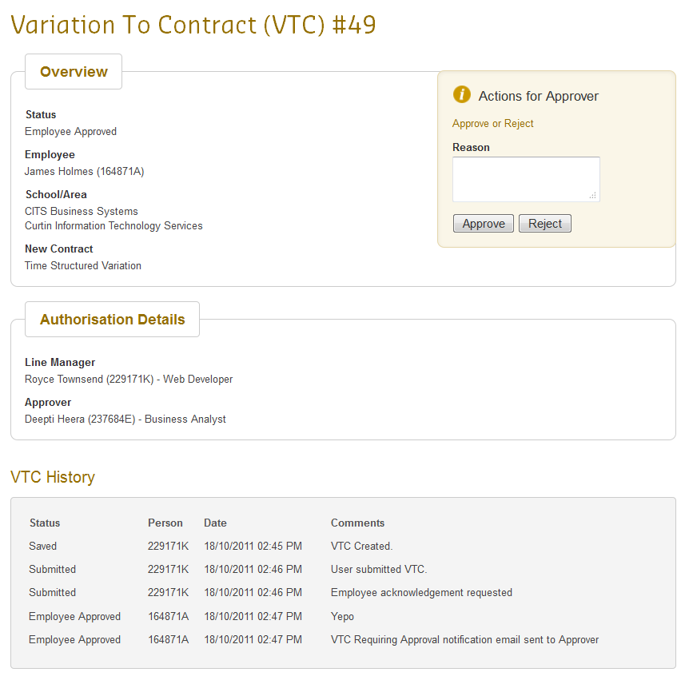
The VTC details will be displayed as well as a history on the actions performed on the VTC.

Approving/Rejecting a VTC
From the previous section (Screen 2), you may select the ‘Approve’ button if all the VTC details are correct. No reason will be required if you approve a VTC.
If the details are incorrect and you want to reject the VTC, then you will need to provide the reason.

Screen 3
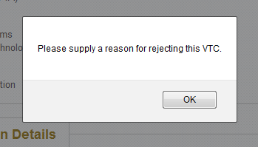

Rejecting a VTC will send an email to the Supervisor (person who placed the VTC request) as well as the employee. If there is a releasing approver involved then he/she will be copied in the rejection email as well.
Once a VTC had been approved by the Area Approver and Releasing Area Approver (if applicable), an email will be sent to HR to process the VTC.

Reminder Emails
If you haven’t approved or rejected a VTC for which you are an approver, an email will follow every 2 days after the original email has been sent to you.
An example of the reminder email is displayed below.

Screen 4
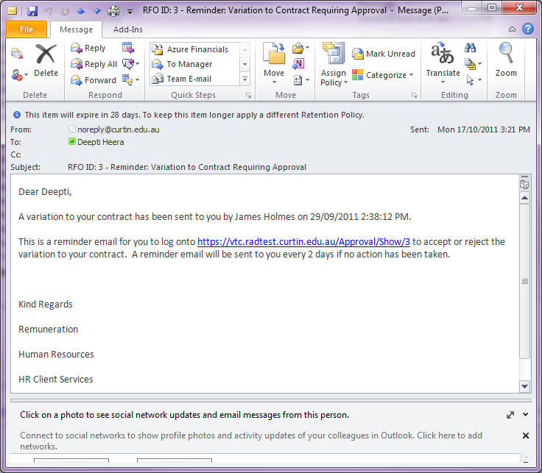

Final Acknowledgement Email
Once a VTC has been processed and approved by HR, an email will be sent to the Supervisor, Employee and Approver(s). An example of the email is displayed below.

Screen 5
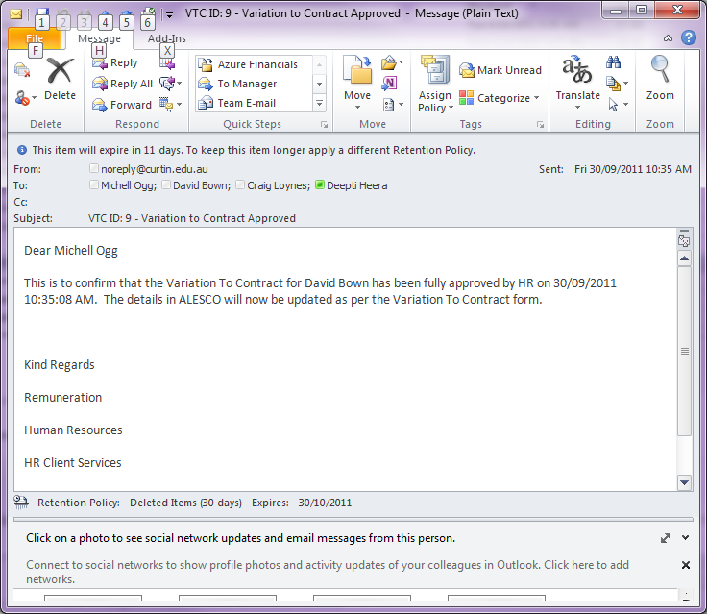
Likewise, if the VTC is rejected by HR, then an email will be sent to the Supervisor, Employee and Approver(s) with the rejection reasons.

